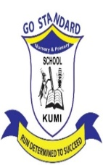
GO-STANDARD NURSERY & PRI-SCHOOL
END OF YEAR EXAMINATION 2023
MIDDLE CLASS: (4 – 5 YEARS)
LEARNING AREA 3: HEALTH HABITS

My name is: …………………………………..………………………….
My School is: ……………………………..………….…………………..
I am in: ………………………………..………………………………………………..
- Name the things found in the kitchen.
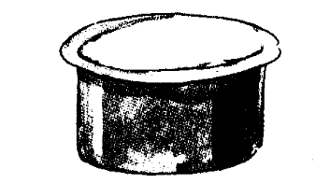
__________________
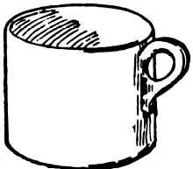
___________________

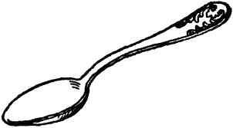
___________________
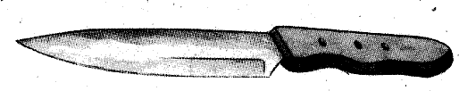
___________________
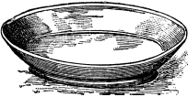
__________________
(saucepan, cup, plate, spoon, knife)

- Draw the dangerous objects.
panga pin

broken bottle knife

razorblade

- Name the things used to clean our bodies.
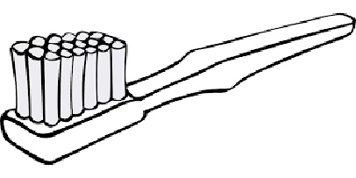 | 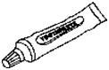 | 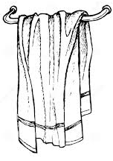
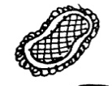 |  | 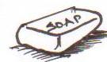

(sponge, soap, toothpaste, water, toothbrush, towel)

- Match people to their place of work.

teacher police station

nurse school

doctor kitchen

police man hospital

cook clinic

End.

